
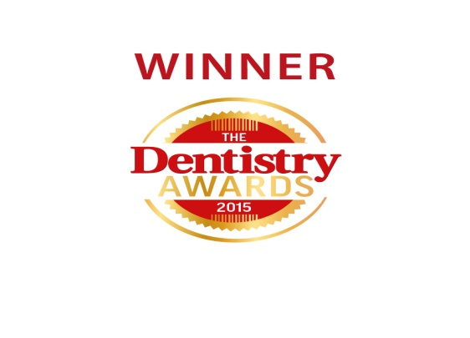
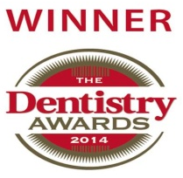

Summer Newsletter 2017
Welcome to the most recent edition of our newsletter, we like to keep you up
to date with what is happening here at Bateman and Best.



- We welcomed a new Foundation Hygiene Therapist to our team in April, Hannah Blanchard. Hannah has been wonderful since starting here and has become a part of the Bateman and Best family with ease! We’re glad to have you here, Hannah!
- We also welcomed two final year hygiene therapy students in February, Danielle and Suzanne. They have been a fantastic part of the team, who help us to offer an excellent service to our patients, and we are thoroughly enjoying working with them!



- One of our associate dentists, Dr Matthew Goodall, recently completed his Masters degree in Restorative Dentistry. Well done, Matt!

- We currently have 3 nurses; Juwairiyah, Morgan and Robyn, working towards achieving their Oral Health Education Certificate. We wish all three ladies the best of luck and look forward to seeing them in their own clinics, offering an extra oral health service to all of our patients!


New NHS Prototype Contract

Since 1st April 2016, we have been working under a new NHS prototype scheme implemented by both the NHS and the Department of Health. This scheme is looking at new ways to provide services and improve overall oral health.

The scheme has a strong emphasis on preventative measures, motivation, and encouragement of self-care. You may find staff spending more time with you discussing things like disease prevention, risk factors, dietary advice and even demonstrations. So far, we are pleased with the new prototype and will keep you informed of any further changes.

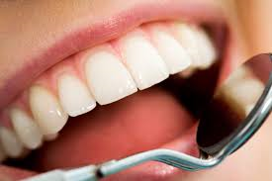

Have your say

A feedback system has been in place, across all NHS organisations, since 1st April 2015, which gives patients the chance to give feedback to help improve your services.

Here at Bateman and Best, we do our best to deliver a high standard of care to our patients. We would greatly appreciate if you could give us your feedback via the comments box at reception. Please let us know what you think we are doing well and what you think we can improve on. Thank you.

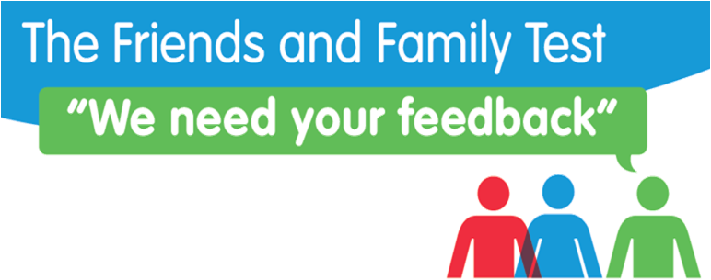

Online Booking System

We now offer an online booking system for patients. All you have to do is give us your email address and you can book appointments whenever or wherever is convenient for you. Please call the practice or ask at reception if you are interested in this service or would like more details.

Summer offers

Teeth Whitening

Would you like to have a whiter, brighter smile this summer?

We thought so!

Throughout August 2017, we are offering our teeth whitening treatment at a 10% discount – That means you’ll pay £292.50, instead of the usual price of £325...

All you have to do to take advantage of this fantastic offer is speak to a member of our reception staff.

Go on, treat yourself!

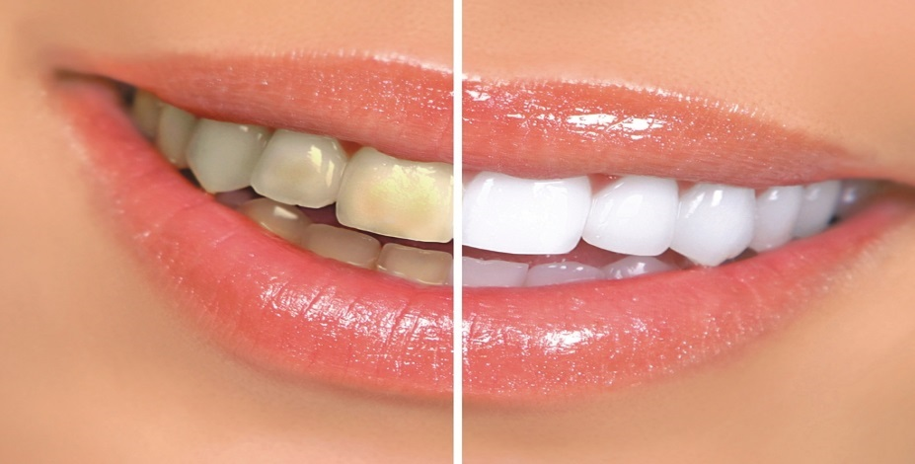

Airflow (Private stain removal)

Did you know we can remove staining caused by tea, coffee, wine etc using our airflow cleaning system?

The therapist uses a focused jet of compressed air, water and bicarbonate particles to gently polish away surface staining.

This treatment is usually £49, however, if you book before 1st September, you can get it at the summer discount price of £39.20 – That’s 20% off!!!

If you are interested in this treatment, please speak to a member of our reception staff and book and appointment.

