
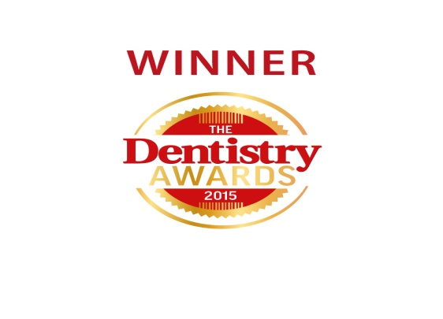
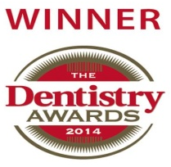

Summer Newsletter 2016
Welcome to the most recent edition of our newsletter, we like to keep you up to date with what is happening here at Bateman and Best.


- In May, we welcomed back Ainsley Punch after returning from maternity leave with baby Ivor.


- Congratulations to Nicole Chapman, who is now a fully qualified Dental Nurse and GDC registered.

- At the end of August we will be saying goodbye to Saimah and Aneesa, our Foundation dentists as they will have completed their foundation year and move on to new practices. Good luck, ladies!

- However, we will be welcoming two new foundation dentists, Robert Highton and James Greenwood in September. Robert and James are newly qualified
dentists and we can’t wait to see them progress over the next 12 months.

- In June we sadly said goodbye to our Head Receptionist Berni. Berni has worked at the practice for the past 11 years. She has moved on to manage two practices in Manchester. She will be sadly missed and a big loss, but we wish her well in her new role.

- Cassie, one of our existing dental nurses has stepped into the Head Receptionist role. She is excited for the challenges that the new role may bring. If you have any questions or queries she will be more than happy to try and help.

- In April, we welcomed a new dentist to the practice, Louise Banner. Louise brings with her a wealth of experience from a previous practice. She currently works in the practice on a Friday, and is a great asset to the team and our patients.

- Two of our dentists are currently studying for their Masters. Michael Best is studying for his masters in orthodontics, and Matthew Goodall is studying for his restorative masters.


- Good luck to all our staff in education – keep going – we currently have PGCE’s, Masters’, Dental Nursing NVQ’s, Nutrition Courses and Sign Language going on. It’s lovely to see our team inspired to learn and progress.
New NHS Prototype Contract

Since 1st April 2016, we have been working under a new NHS prototype scheme implemented by both the NHS and the Department of Health. This scheme is looking at new ways to provide services and improve overall oral health.

The scheme has a strong emphasis on preventative measures, motivation, and encouragement of self-care. You may find staff spending more time with you discussing things like disease prevention, risk factors, dietary advice and even demonstrations.
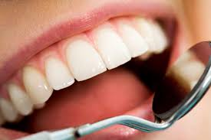

Have your say

A new feedback system will be in place from 1st April 2015 across all NHS organisations, which gives patients the chance to give feedback to help improve your services.

Here at Bateman and Best, we do our best to deliver a high standard of care to our patients. We would greatly appreciate if you could give us your feedback via the comments box at reception. Please let us know what you think we are doing well and what you think we can improve on. Thank you.

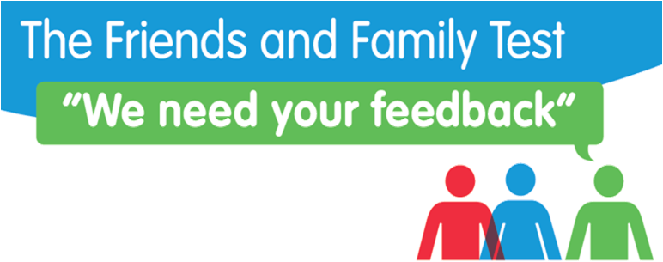

Online Booking System


We now offer an online booking system for patients. All you have to do is give us your email address and you can book appointments whenever or wherever is convenient for you. Please call the practice or ask at reception if you are interested in this service or would like more details.

Summer offers


Would you like to have a whiter, brighter smile for Summer. We currently have a summer special offer on tooth whitening – usually £325…

Summer Price = £299 (until 1st September 2016)

If you would be interested in taking up this fantastic offer, please speak to reception staff.

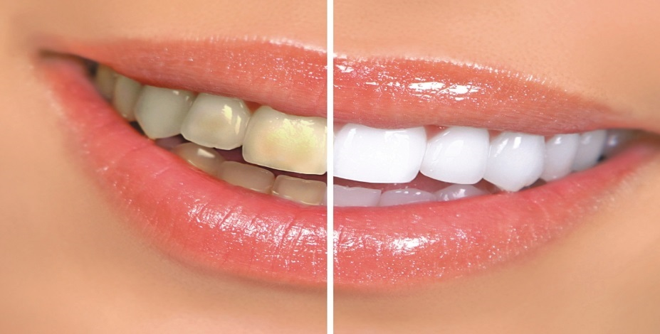

Airflow (Private stain removal)

Did you know we can remove staining caused by tea, coffee, wine etc using our airflow cleaning system. The therapist uses a focused jet of compressed air, water and bicarbonate particles to gently polish away surface staining.

If you book this in with the therapist before 1st September 2016, you can get it at the summer discounted price of £29 (usually £40)!!!!

